CONFIDENTIAL CS/OCT 2026/MAT133

UNIVERSITI TEKNOLOGI MARA FINAL EXAMINATION

COURSE
COURSE CODE
EXAMINATION TIME
PRE CALCULUS
MAT133 OCTOBER 2026
2 HOURS

INSTRUCTIONS TO CANDIDATES

- This question paper consists of 5 questions.

- Answer ALL questions in the Answer Booklet. Start each answer on a new page.

- Do not bring any material into the examination room unless permission is given by the invigilator .
- Please check to make sure that this examination pack consists of: i) the Question Paper
  - a one - page Append ix 1
  - an Answer Booklet - provided by the Faculty
  - a graph paper - provided by the Faculty

- Answer ALL questions in English.

/

DO NOT TURN THIS PAGE UNTIL YOU ARE TOLD TO DO SO

This examination paper consists of 7 printed pages

QUESTION 1
a) Write the solution of 5x - 7 > 1 in interval notation and on a number line.
(3 marks)
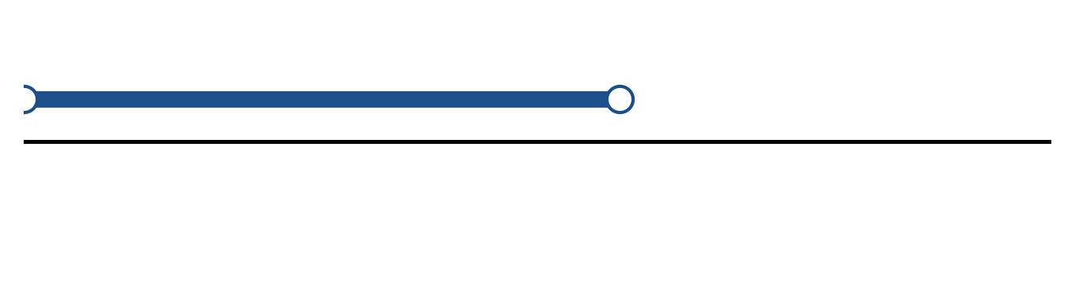
Figure: solution set.
b) Solve the inequality |2x + 5| ≥ 6. Express the answer in interval notation and on a number line.
(5 marks)
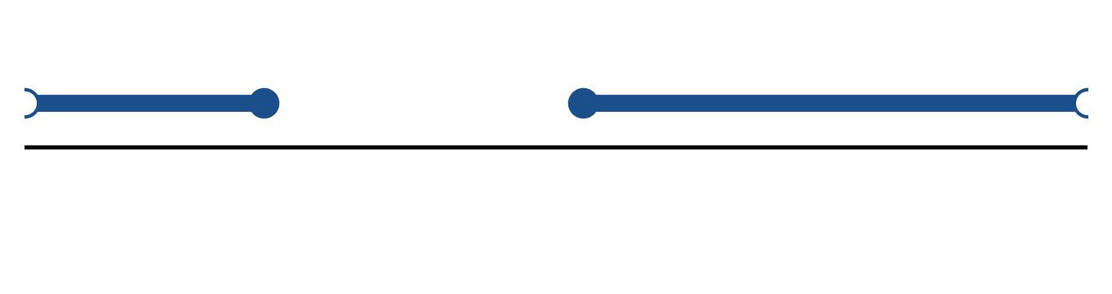
Figure: solution on a number line.
c) Sketch y = 2|x + 1| + 2. State the vertex, the y-intercept and any x-intercepts.
(5 marks)
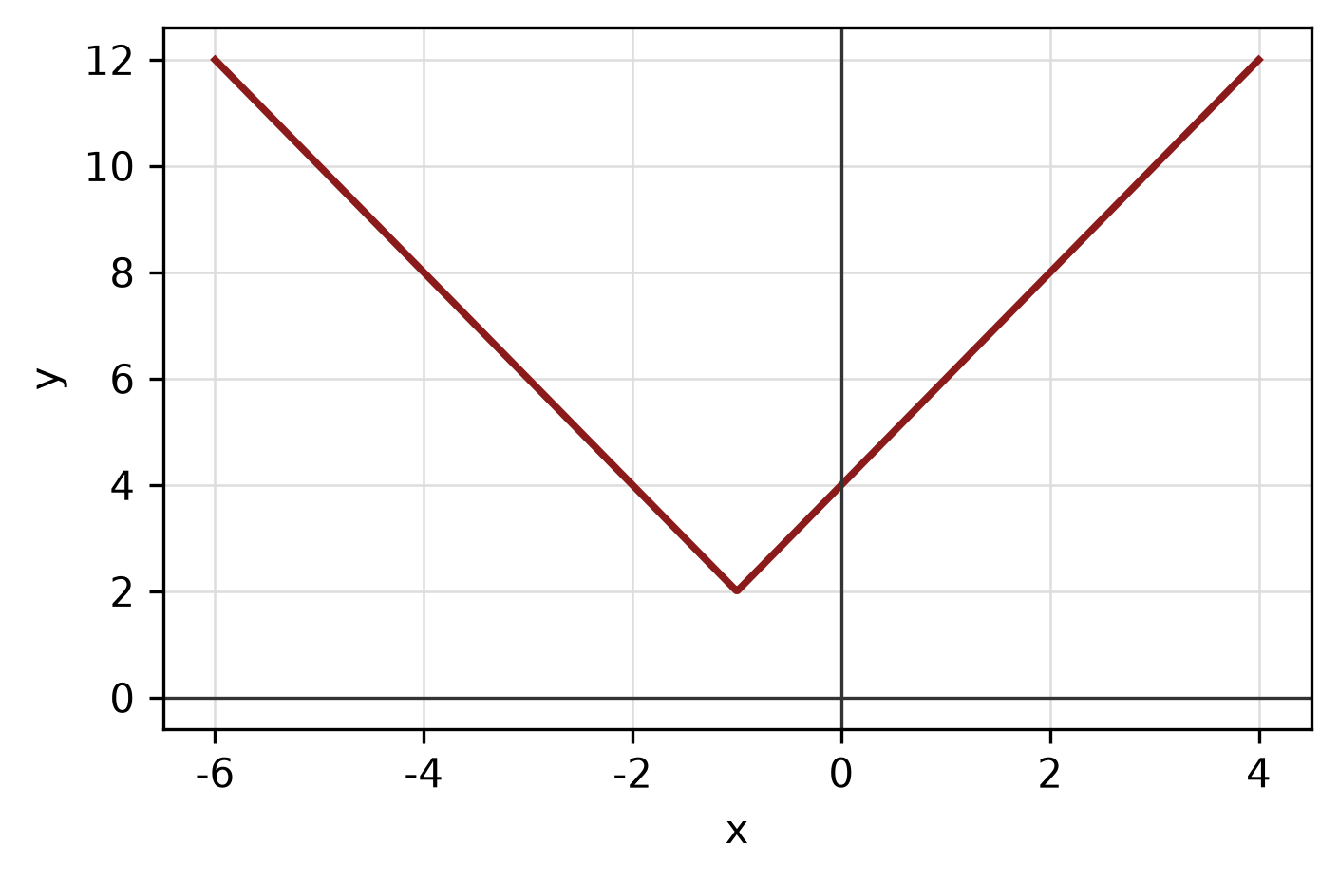
Figure: absolute-value graph.
QUESTION 2
a) Apply graph-transformation techniques to sketch y = -3(x - 2)² - 3. State the vertex and the y-intercept.
(5 marks)
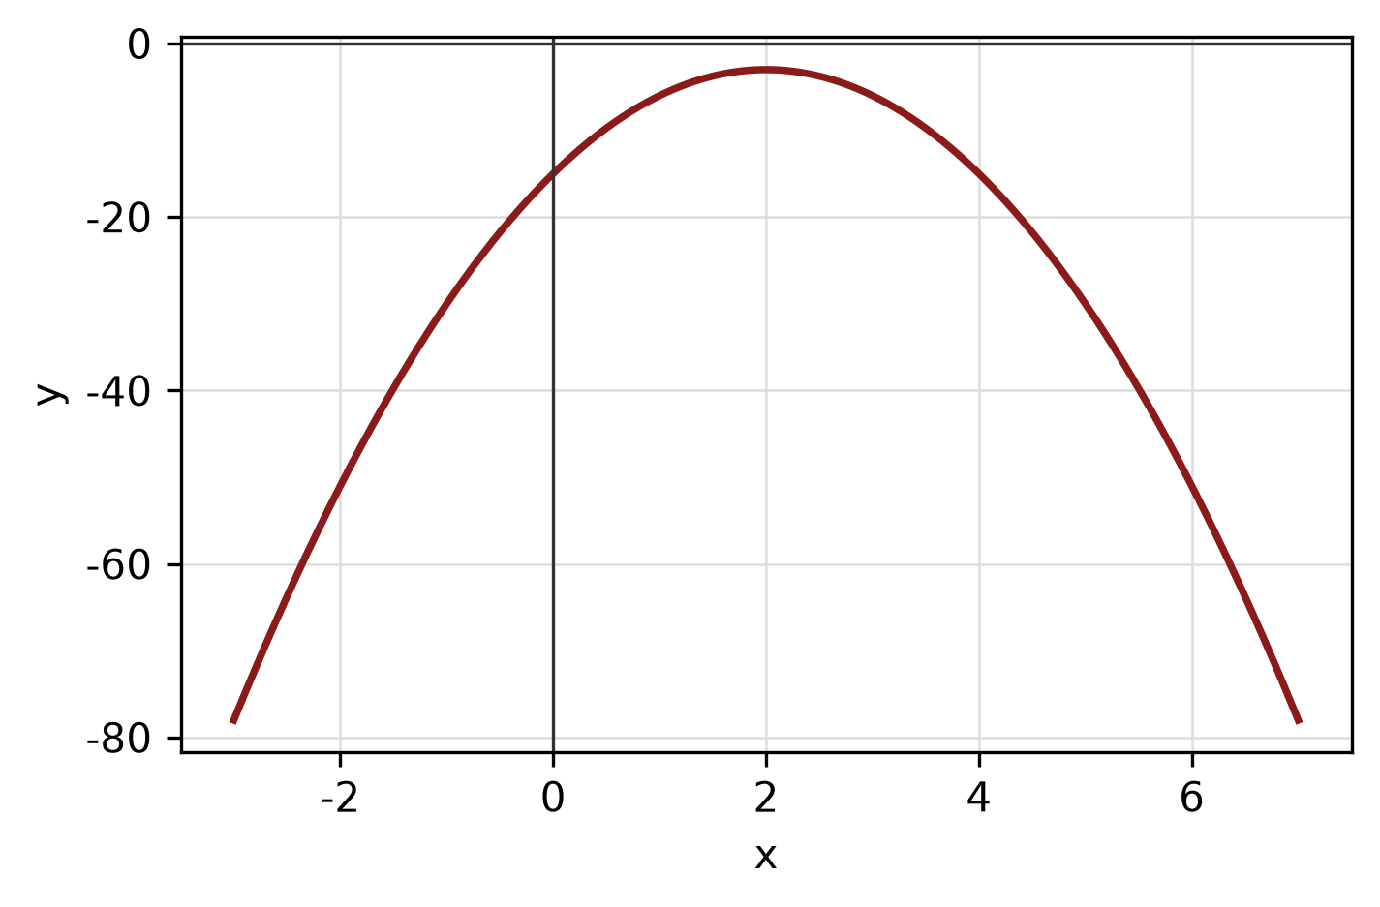
Figure: transformed graph.
b) Sketch y = √(x + 2) for -2 ≤ x ≤ 7. State the domain and range.
(4 marks)
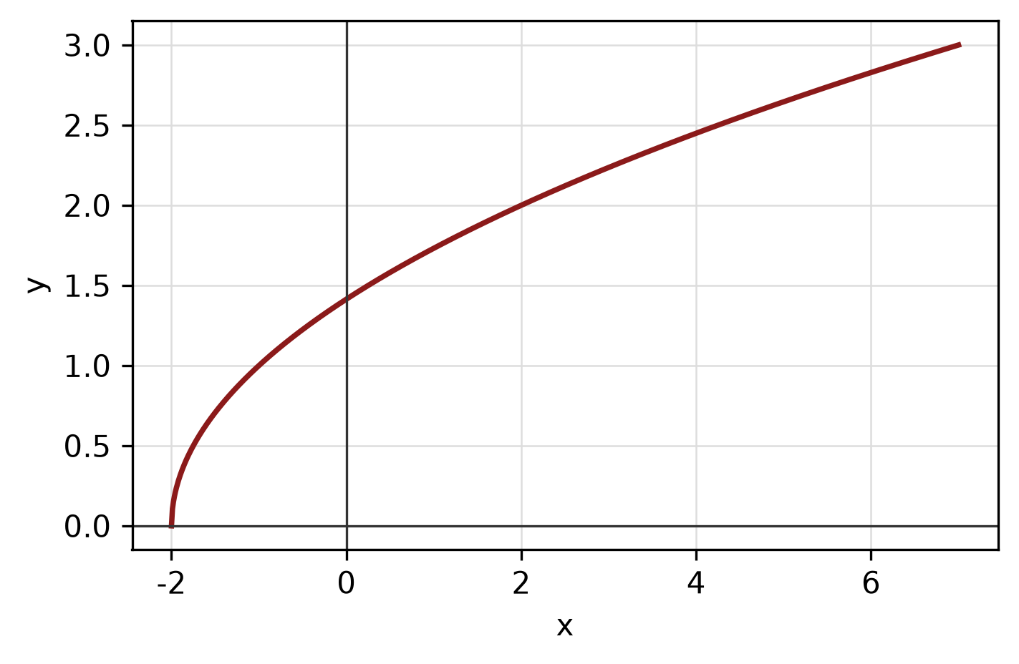
Figure: function graph.
c) Find the equation of the line passing through (2, 3) and perpendicular to the line -5x - y - 6 = 0.
(5 marks)
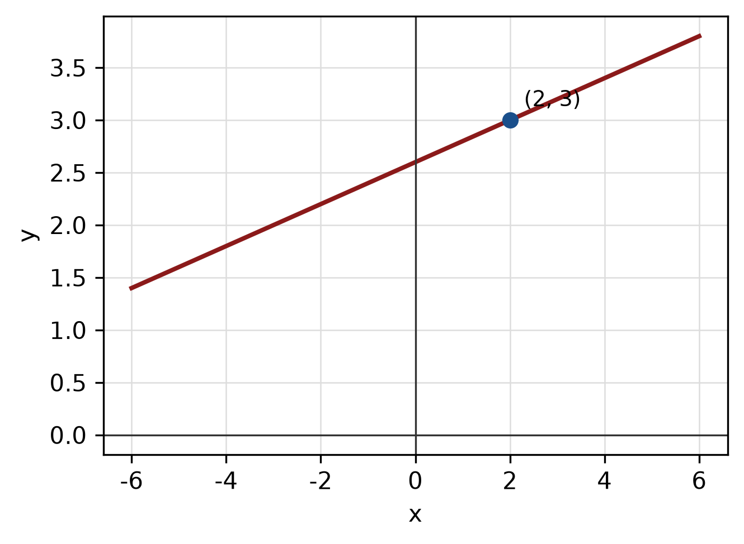
Figure: required line.
QUESTION 3
a) Given z₁ = 4 - 3i and z₂ = -2 + 2i, express z₁/z₂ in the form a + bi.
(5 marks)
b) Find the modulus and argument of z = -5 + 12i. Give the argument in degrees correct to one decimal place.
(5 marks)
c) Show that x + 3 is a factor of f(x) = 3x^3 + 6x² - 13x - 12 by using the factor theorem. Hence factorise f(x) completely.
(5 marks)
QUESTION 4
a) Graph the system of inequalities below and shade the feasible region. State the vertices of the region.
x ≥ 0, y ≥ 0, 1x + 2y ≤ 6.
(5 marks)
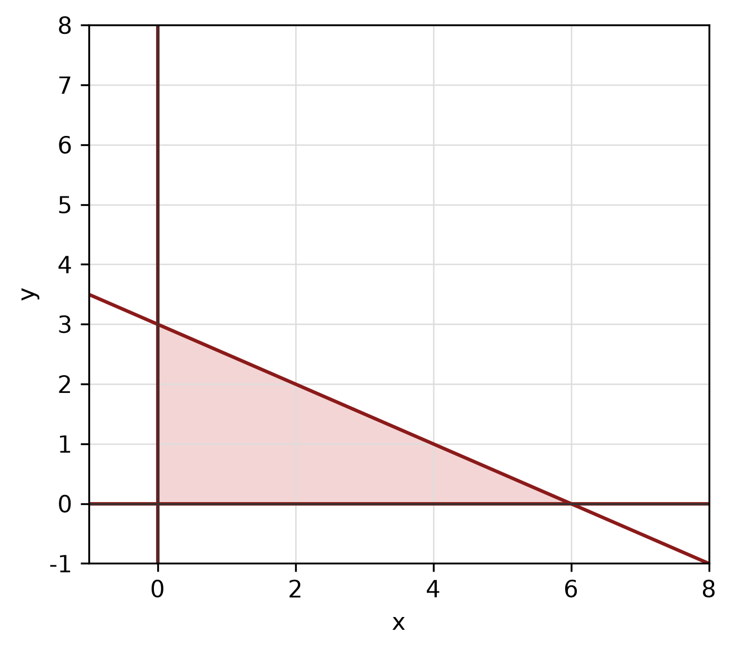
Figure: feasible region.
b) Solve the simultaneous equations
y = x² - 2
y = 7x - 12.
(5 marks)
c) Write y = x²/8 + 3x/4 + 49/8 in standard form. Hence state the vertex, focus and directrix, and sketch the parabola.
(5 marks)
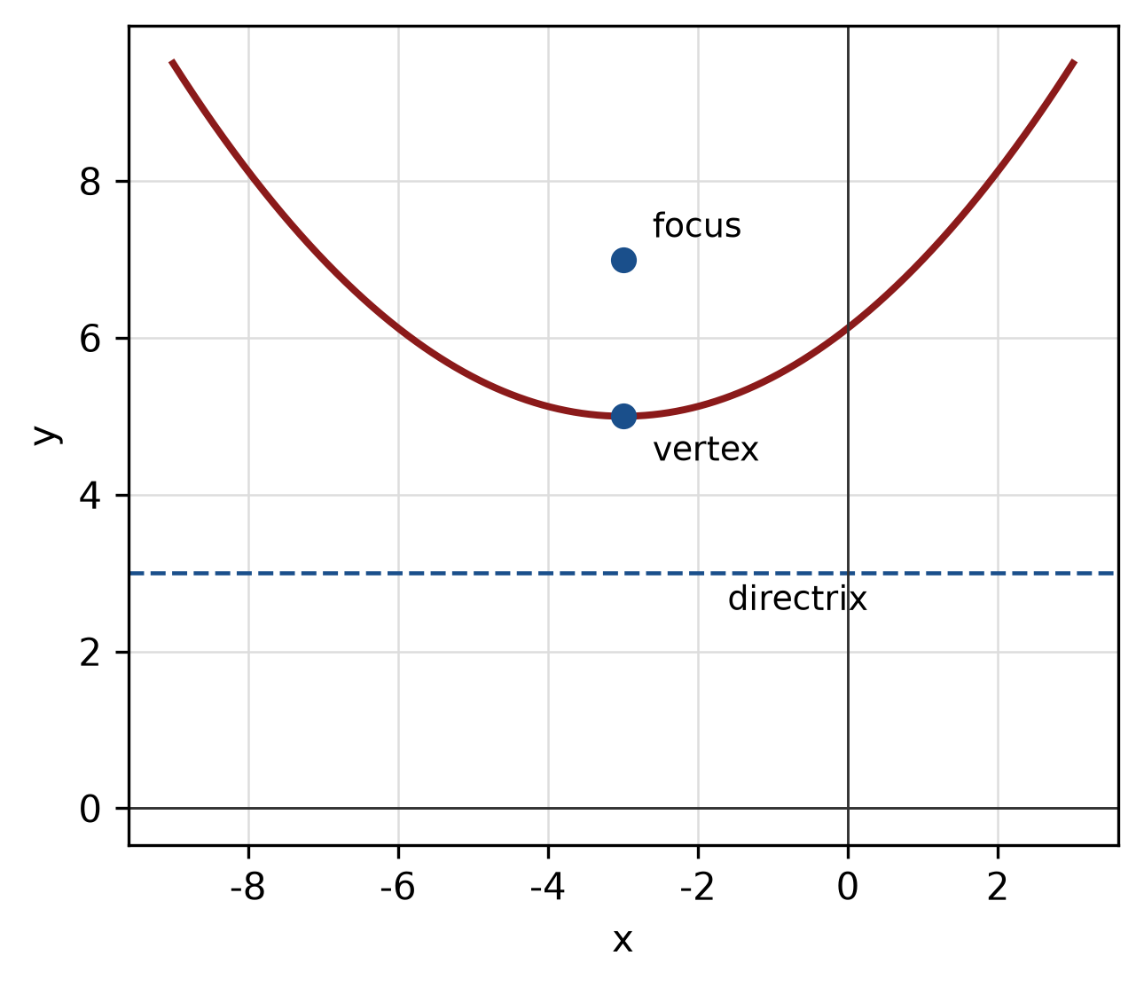
Figure: parabola.
QUESTION 5
a) Given sin A = 8/17 where A is in quadrant II and cos B = 15/17 where B is in quadrant IV, find sin 2A and cos(A + B).
(5 marks)
b) Find the perimeter of the sector with radius 15 cm and central angle 90°.
(4 marks)
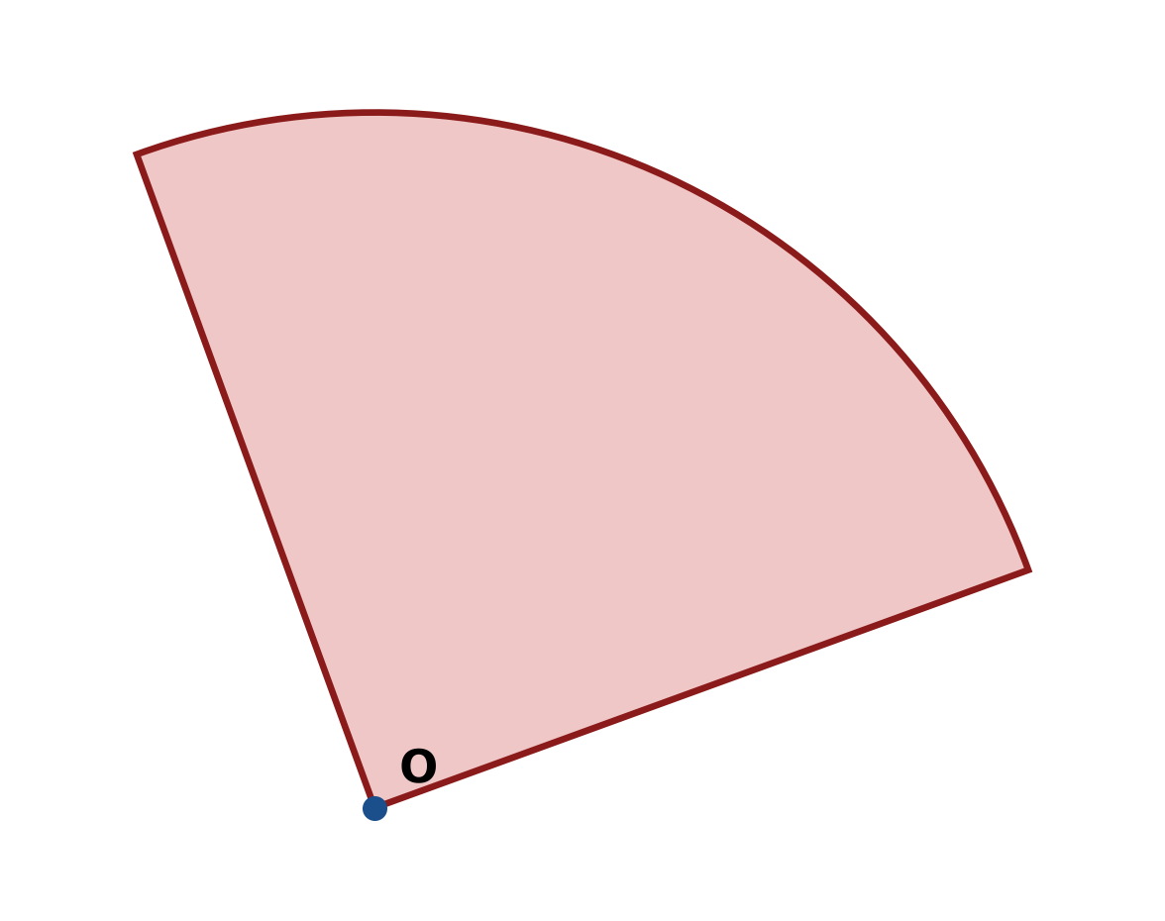
Figure: sector.
c) In triangle ABC, b = 10 cm, c = 11 cm and A = 120°. Use the cosine rule to find a.
(4 marks)
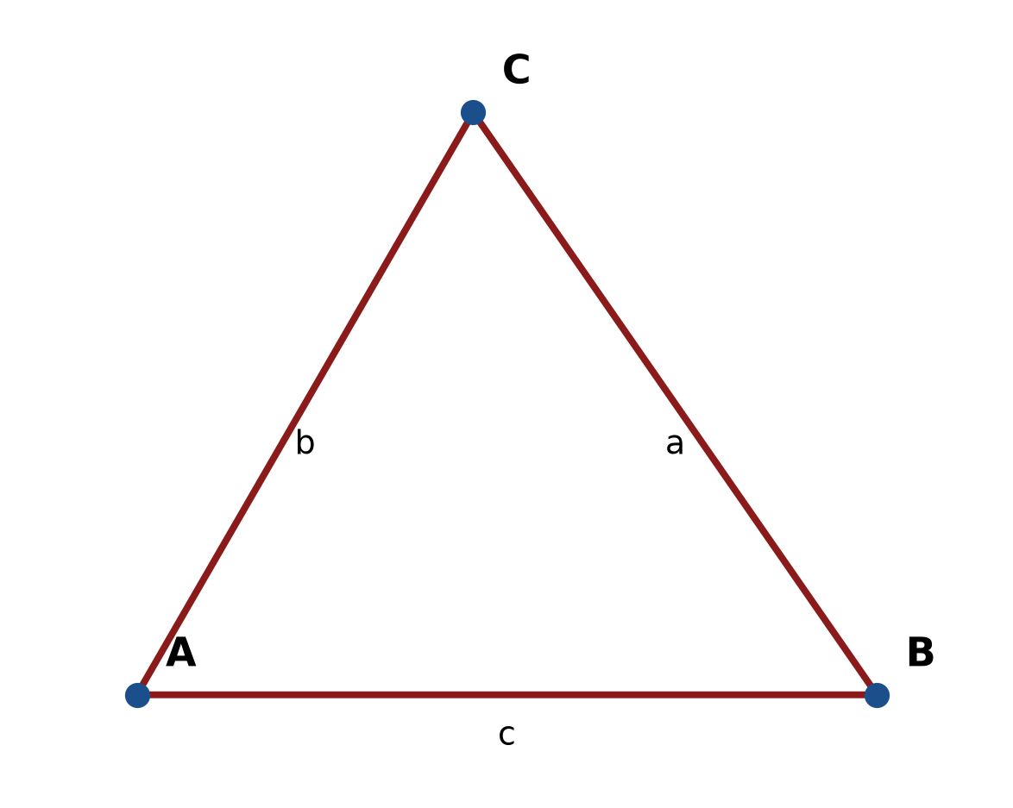
Figure: triangle ABC.
END OF QUESTION PAPER

APPENDIX 1
Formula sheet (as supplied with the paper).
sin² A + cos² A = 1 | tan² A + 1 = sec² A
sin(A + B) = sin A cos B + cos A sin B | tan 2A = 2 tan A / (1 − tan² A)
cos(A + B) = cos A cos B − sin A sin B | Arc length, s = rθ
tan(A − B) = (tan A − tan B) / (1 + tan A tan B) | Area of sector = ½r²θ
cos 2A = cos² A − sin² A | a / sin A = b / sin B = c / sin C
cos 2A = 1 − 2sin² A = 2cos² A − 1 | a² = b² + c² − 2bc cos A
sin 2A = 2 sin A cos A | Area of triangle = ½ab sin C

